AIN SHAMS UNIVERSITY FACULTY OF ENGINEERING

International Credit Hours Engineering Program (i.CHEP)

**Introduction to Bio-Mechatronics**

**MCT343**

**Major Task**

**Prosthetic Finger**

**Submitted to:**

Prof. Mohamed Ibrahim

**Submitted By:**

|  |  |
| --- | --- |
| **Name** | **ID** |
| **Omar Wessam El Din** | 20P8844 |
| **Mostafa Ahmed El-Derei** | 20P5121 |
| **Abdullah Omar Barakat** | 20P5573 |
| **Mohamed Ahmed Emara** | 20P5754 |
| **Fady Sameeh Wadee** | 20P6304 |

Contents

1. Introduction: 4

2. Components Used: 6

3. Design Challenges: 7

4. EMG Sensor: 8

5. CAD Design: 11

6. Circuit: 17

7. Electrodes Placement: 18

8. Final Product: 20

9. Control Code Challenges: 21

10. Conclusion: 24

Table of Figures

Figure 1: Distal 7

Figure 2: middle 8

Figure 3: Proximal 9

Figure 4: Base 10

Figure 5: Assembly Veiw1 11

Figure 6: Final Assembly Veiw2 12

Figure 7: Circuit Diagram 13

Figure 8: Circuit Implementation 13

Figure 9: Electrodes Diagram 14

Figure 10: Final Product 15

# Introduction:

* The objective of this project is to incorporate electromyography (EMG) signal acquisition and utilization for overseeing a basic prosthetic finger. The EMG signals need to undergo amplification and filtration to align with the microcontroller ADC range. The microcontroller is employed to manage the actuator responsible for hand or finger movement. The project presents a practical approach to EMG control for the prosthetic hand through threshold-based control, altering the hand's state between different gesture controls.
* This project aims to harness the potential of electromyography (EMG) technology to enhance the control of a prosthetic finger by capturing signals from the brachioradialis muscle. The brachioradialis muscle, located in the forearm, is chosen for its accessibility and relevance to hand movements. Through the strategic placement of an EMG sensor, we seek to accurately detect and interpret the electrical impulses generated by muscle contractions during various hand gestures. By implementing signal processing techniques such as measurement, rectification, smoothing, and gain adjustment, we aim to refine the raw EMG signals, preparing them for seamless integration with a microcontroller. The ultimate goal is to establish an intuitive and responsive interface, enabling individuals with upper limb amputations to control a prosthetic finger effortlessly, translating their natural muscle signals into precise and coordinated movements. This project holds significant potential to advance the field of prosthetics, offering an innovative and user-friendly solution for individuals seeking improved functionality and dexterity in their daily lives. In addition to the primary objectives outlined, this innovative prosthetic control project is strategically divided into two milestones, each addressing distinct aspects of functionality. The first milestone focuses on achieving proportional control of the prosthetic finger based on muscle activity. Through meticulous calibration and signal processing techniques, the project aims to establish a direct correlation between the intensity of muscle contractions in the brachioradialis and the corresponding movements of the prosthetic finger. This proportional control milestone emphasizes precision and responsiveness, providing users with the ability to modulate the prosthetic finger's actions in proportion to their muscle activity.
* Building upon the success of the proportional control milestone, the project's second milestone introduces sequential control. This advanced stage involves detecting specific sequences of muscle activity to trigger predefined positions or actions of the prosthetic finger. By implementing sophisticated algorithms and pattern recognition techniques, the system will interpret distinct muscle activity patterns associated with various hand gestures or tasks. Users will be able to seamlessly transition between different functional modes, allowing the prosthetic finger to apply specific positions or perform predefined actions based on the detected muscle activity sequence.
* **Key specifications include:**
  + Utilizing a single EMG channel for hand control.
  + Designing the finger's mechanical structure based on robust mechanisms, moving finger links without relying on a wire or cable mechanism.
  + Ensuring a minimum of 1 Actuated Degree of Freedom (DOF) in the prosthetic finger.
  + Incorporating at least 2 EMG controllers: Proportional Control and Sequential Control.
  + Running the prosthetic finger prototype on an embedded system development board, excluding the use of laptops or PCs.

# Components Used:

|  |  |
| --- | --- |
| Electrical components & Actuators | |
| Servo motor SG90 |  |
| Arduino |  |
| EMG sensor |  |
| Battery 9v |  |
| Jumpers |  |
| Sensing electrodes |  |

All Designed mechanical parts were 3D printed.

All Bolts used are M3.

# Design Challenges:

We faced some design challenges, and they can be divided into:

* **Range of Motion:** Achieving a natural range of motion and dexterity similar to a human finger is challenging. Mimicking the complex movements of the human hand requires precise engineering. This necessitates a highly precise mechanical design, carefully orchestrating the placement of servo motors, linkages, and joints. Overcoming mechanical issues such as backlash and friction is essential to ensure the prosthetic finger moves seamlessly and responsively, mimicking the intricacies of human hand movements.
* **Sensory Feedback:** Providing realistic and intuitive sensory feedback is crucial for the user to interact with the environment. Integrating sensors into the prosthetic that can replicate tactile sensations, requires a sophisticated design approach. The challenge is not only in the hardware implementation of these sensors but also in creating software algorithms that interpret the sensory data in real-time, enhancing the overall user experience.
* **Weight and Size:** Balancing the weight and size of the prosthetic finger is important to ensure comfort and ease of use. Incorporating servo motors and associated components demands a delicate balance between a robust structural design and a lightweight frame. Achieving this equilibrium is crucial for practical and prolonged use, as it directly influences the prosthetic's wearability and user acceptance.
* **Adaptability to Various Grips and Tasks**: Ensuring the prosthetic can adapt to different grips and perform various tasks is challenging.

# EMG Sensor:

Figure 1: EMG Sensor wiring

EMG sensors are designed to capture electrical impulses generated by muscle contractions, and when paired with a dedicated microcontroller, they enable real-time monitoring and analysis of muscle activity. This integration allows for precise and responsive control systems in fields such as biomechanics, prosthetics, and human-computer interaction. The microcontroller processes the analog signals from the EMG sensor, converts them into digital data, and executes programmed algorithms to interpret muscle activity patterns.

The EMG sensor used is specifically designed for integration with microcontrollers, it implies a seamless and optimized interface between the two components. This specialized design likely streamlines the process of connecting the sensor to the microcontroller, ensuring compatibility and efficient communication. Such integration simplifies the task of capturing muscle signals, as the sensor's output is tailored to the microcontroller's input requirements.

* A diagram of a circuit

  Description automatically generated**Circuit Schematic:**

Figure 2:Circuit Diagram for EMG sensor

The EMG sensor's signal processing stages, which include measurement, rectification, smoothing (filtering), and gain adjustment, play a crucial role in preparing the muscle signal for compatibility with a microcontroller. By sequentially executing these stages, the sensor refines the raw muscle signal to make it suitable for interpretation by the microcontroller. The measurement stage captures the electrical impulses generated by muscle contractions. Subsequently, rectification converts the alternating current nature of the signal into a unidirectional flow, facilitating further processing.

* A diagram of waves with lines and text

  Description automatically generated with medium confidence**Measurement Stage:** The measurement stage in EMG signal processing is fundamental, capturing the electrical impulses generated by muscle contractions. This initial step provides a raw representation of the muscle activity, serving as the foundation for subsequent processing stages. The accuracy and precision of this stage are critical, as any discrepancies or noise introduced here may compromise the overall quality of the muscle signal data. It involves the differential amplification of two surface electrode recordings from a muscle.
* **Rectification Stage:** Following the measurement stage, the rectification process converts the alternating current nature of the signal into a unidirectional flow. This is typically achieved through half-wave or full-wave rectification. By rectifying the signal, the negative components are converted to positive, simplifying further analysis and interpretation. This stage is crucial for ensuring a consistent and standardized signal format, facilitating subsequent stages of signal processing and analysis. The inversion of the negative part of the signal is particularly relevant for microcontroller compatibility, as microcontrollers often operate with positive voltage signals. By inverting the negative portion of the signal, the EMG sensor ensures that the resulting output aligns with the microcontroller's input requirements.
* **Smoothing (Filtering) Stage:** Smoothing, achieved through filtering techniques, is essential for eliminating unwanted noise and high-frequency components present in the raw muscle signal. Filtering enhances the signal-to-noise ratio and produces a more stable and reliable representation of muscle activity. The choice of filter parameters is crucial, as it influences the trade-off between preserving the relevant signal information and removing unwanted artifacts. A low pass filter is used to only pass the small frequencies required while cutting off higher frequency noise.
* **Gain Adjustment Stage:** The gain adjustment stage focuses on scaling the signal to optimize its amplitude for the specific requirements of the microcontroller. Proper gain adjustment enhances sensitivity and ensures that the signal falls within the desired voltage range, maximizing the dynamic range of the system. This stage is vital for achieving accurate and responsive readings, especially in applications where subtle changes in muscle activity need to be captured and translated into meaningful data.

Each of these stages plays a crucial role in the signal processing pipeline, collectively preparing the muscle signal for effective interpretation by a microcontroller. The integration of these stages ensures that the processed signal aligns with the microcontroller's input specifications, facilitating seamless utilization in a wide range of applications, from medical devices to human-machine interfaces.

# CAD Design:

Figure : Distal

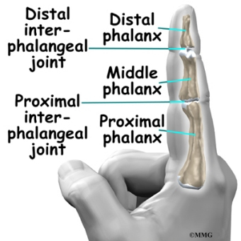

Figure : middle

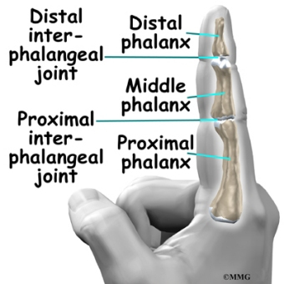

Figure : Proximal



Figure : Base

Figure : Assembly Veiw1

Figure : Final Assembly Veiw2

# Circuit:

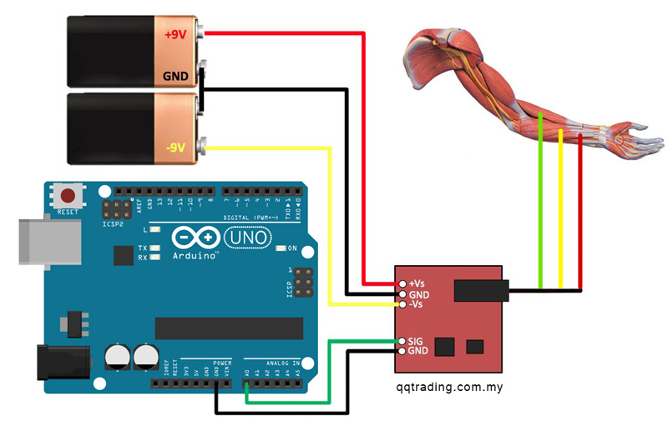

Figure : Circuit Diagram

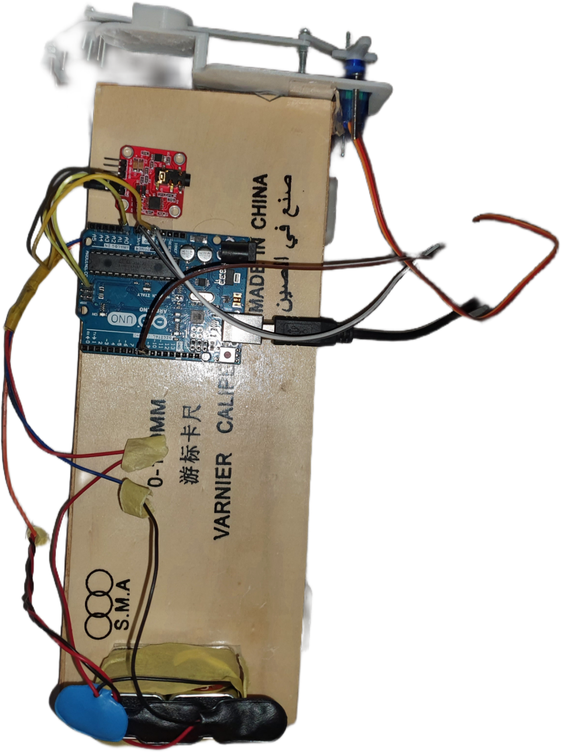

Figure : Circuit Implementation

# Electrodes Placement:

Figure : Electrodes Diagram

Electrode placement in electromyography (EMG) is a critical aspect that significantly influences the accuracy and reliability of muscle signal acquisition. In the context of our prosthetic finger control project, the selection of the brachioradialis muscle for electrode placement holds specific significance for several reasons. The brachioradialis muscle, situated in the forearm, is chosen due to its accessibility and relevance to hand movements. Placing electrodes over this muscle allows us to capture electromyographic signals associated with a variety of hand gestures and finger movements, providing a comprehensive representation of the user's intended actions.

The brachioradialis muscle's unique anatomical location makes it well-suited for capturing signals related to hand and finger control. This muscle is involved in various hand movements, including wrist extension and flexion, as well as radial deviation. These actions are fundamental to performing everyday tasks and are crucial for intuitive and natural control of a prosthetic finger. By selecting the brachioradialis muscle, we aim to capture a diverse range of muscle signals that can be translated into nuanced and precise control of the prosthetic device.

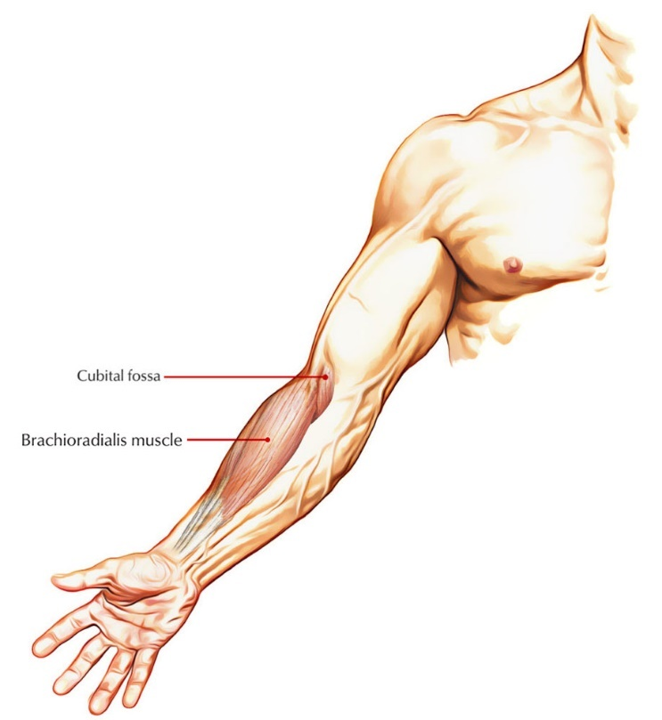Additionally, the brachioradialis muscle is relatively superficial, making electrode placement more straightforward and less invasive. This accessibility enhances user comfort and facilitates the practical implementation of the EMG sensor in a prosthetic control system. The ease of electrode placement is particularly advantageous for ensuring consistent and reliable signal acquisition, minimizing the potential for interference or inaccuracies in muscle signal readings.

Furthermore, the brachioradialis muscle is relatively less prone to fatigue compared to some other muscles, making it suitable for sustained use in real-world scenarios. This characteristic is essential for users who may rely on the prosthetic finger for extended periods throughout the day. The selection of the brachioradialis muscle aligns with our goal of creating a user-friendly and efficient interface, providing users with a reliable and fatigue-resistant means of controlling their prosthetic device.

In summary, the choice of the brachioradialis muscle for electrode placement in our EMG sensor is based on its accessibility, relevance to hand movements, ease of placement, and resistance to fatigue. These considerations collectively contribute to the successful acquisition of muscle signals, enabling intuitive and natural control of the prosthetic finger for enhanced user experience and functionality.

# Final Product:

Figure : Final Product

# Control Code Challenges:

Developing the software code to control the prosthetic finger posed significant challenges, primarily centered around mitigating the noise inherent in the electromyography (EMG) sensor readings. The noisy signals, a common issue in EMG applications, required meticulous filtering strategies to ensure accurate and reliable interpretation of muscle signals for prosthetic control. Three distinct filtering steps were implemented to address the noise challenges.

1. Firstly, a second-order filter was applied to the raw EMG signals. This filter played a crucial role in attenuating high-frequency noise components while preserving the essential muscle signal information. The second-order filter's design allowed for a targeted reduction in noise, providing a cleaner signal for subsequent processing stages.
2. Secondly, a root mean square (RMS) value calculation was employed for a window of 100 readings. The RMS calculation helped smooth out fluctuations in the signal by providing a representative value over a short time window. This approach was effective in reducing high-frequency noise, contributing to a more stable representation of the underlying muscle activity.
3. Lastly, a first-order exponential moving average (EMA) filter was applied for its ease of implementation and adaptability. The EMA filter smoothed the signal by assigning exponentially decreasing weights to past readings, effectively filtering out rapid variations and emphasizing the overall trend. The simplicity and adaptability of the first-order EMA filter made it a suitable choice for real-time processing, ensuring responsiveness in prosthetic control.

Despite these filtering strategies, challenges persisted in fine-tuning the filter parameters to strike a balance between noise reduction and signal preservation. Optimizing these parameters required iterative testing and adjustment to account for individual variations in muscle signals and user-specific characteristics.

In addressing the need for dynamic adaptation to changing muscle conditions and user requirements, the software code incorporated a mechanism that relied on the average value of the EMG sensor output. The implementation involved continuously monitoring the average EMG signal level and establishing a baseline for normal muscle activity. This baseline served as a reference point, allowing the system to discern significant deviations and adapt accordingly. The software code employed a strategy of ignoring minor fluctuations in the EMG signal unless a noticeable change occurred relative to the established average. This approach helped filter out insignificant noise or variations attributable to minor muscle contractions, promoting stability in the control system. By setting a threshold for significant changes, the software distinguished intentional signals indicative of different grips, tasks, or user preferences from background noise.

The software development aspect of this project presented a unique challenge that demanded a delicate balance between minimizing code size for system speed and ensuring robust software filtering of electromyography (EMG) sensor readings. The primary goal was to optimize the code for minimal execution time, eliminating any noticeable delays in the prosthetic finger's responsiveness. Simultaneously, it was crucial to implement effective software filtering to refine the raw EMG signals for accurate interpretation and control.

It's essential to acknowledge the inherent complexity of this challenge, as the fastest software solution might still be slower than the slowest hardware alternative. The team navigated this dilemma by employing efficient algorithms and ensuring that the software-based filtering maintained a high level of precision while meeting the stringent timing requirements for real-time prosthetic control.

Figure 13: Software filtering delay

In summary, developing the software code for prosthetic control faced substantial challenges related to the inherent noise in EMG sensor readings. The implementation of a second-order filter, RMS calculation for noise reduction, and a first-order EMA filter aimed to address these challenges, emphasizing a balance between noise reduction and responsiveness in the prosthetic control system. The iterative nature of parameter tuning and the need for adaptability added complexity to the software development process, ultimately contributing to a robust and effective solution for EMG-based prosthetic control.

# Conclusion:

In conclusion, this project endeavors to revolutionize prosthetic control by leveraging electromyography (EMG) technology to capture signals from the brachioradialis muscle. The strategic placement of an EMG sensor in the forearm provides accessibility and relevance to hand movements. Through a systematic approach involving signal processing techniques such as measurement, rectification, smoothing, and gain adjustment, the project aims to refine raw EMG signals, paving the way for seamless integration with a microcontroller. The ultimate goal is to establish an intuitive and responsive interface, allowing individuals with upper limb amputations to effortlessly control a prosthetic finger through the translation of natural muscle signals into precise and coordinated movements.

This groundbreaking initiative unfolds in two milestones. The first milestone centers on achieving proportional control, correlating the intensity of muscle contractions with corresponding prosthetic finger movements. This precision-driven approach enables users to modulate the prosthetic finger's actions in direct proportion to their muscle activity, enhancing control and responsiveness. Building on this success, the second milestone introduces sequential control. By detecting specific sequences of muscle activity, the system triggers predefined positions or actions of the prosthetic finger. This advanced stage further enriches user experience, allowing for a diverse range of functional applications and empowering users to seamlessly transition between different gestures and tasks.

The project's significance lies not only in its technical advancements but also in its potential to profoundly impact the lives of individuals with upper limb amputations. The innovative two-tiered control system, combining proportional and sequential control, embodies adaptability and responsiveness, offering a comprehensive solution that addresses the varied needs and preferences of users. This project holds the promise of advancing the field of prosthetics, providing an innovative and user-friendly solution that significantly enhances functionality and dexterity, ultimately contributing to an improved quality of life for its users.

In summary, this project represents a pioneering effort in the realm of prosthetic technology, harnessing the potential of EMG signals for precise and intuitive control. The development process encompassed various engineering disciplines, from biomechanics to signal processing, resulting in a prosthetic finger that holds great promise for individuals seeking improved functionality and dexterity. This work opens avenues for future advancements in prosthetic design and control, providing a foundation for more sophisticated and user-friendly solutions in the field.

Drive link for Video:

[BIO - Google Drive](https://drive.google.com/drive/folders/1duBusxz4DSQEk0fGOirPiKUQwssdqGsH)